### Ex.No. : 04 Date:010.02.2025

**RegisterNo.:221701004 Name:Adhithya A**

AndroidFragments

# Aim

Develop an android application to create Two activity named as Student Basic Details(name,age, address)and StudentMark(Marks,Total,Grade,Status).Writeanandroidcodetocombinethesetwoactivitiesinsinglescreenusingandroid fragment.

## Procedure:

**Step1:**File->NewProject

ProvidetheapplicationnameandClick“Next”

**Step2:**Selectthetargetandroiddevices

SelecttheminimumSDKtoruntheapplication.Click“Next”.

**Step3:**Choosetheactivityfortheapplication(Bydefaultchoose“BlankActivity).

Click “Next”.

**Step4:**Enteractivitynameandclick&quot;Finish&quot;.

**Step5:**Edittheprogram.

**Step 6:** Runtheapplication,2-waystorunthe application.

1. Runningthroughemulator
2. Runningthroughmobiledevice

**DepartmentofComputerScienceandDesign**| **RajalakshmiEngineeringCollege**

.

1

## AndroidManifest.xml

<?xmlversion="1.0"encoding="utf-8"?>

<manifest xmlns:android="<http://schemas.android.com/apk/res/android>"xmlns:tools=["http://schemas.android.com/tools](http://schemas.android.com/tools)">

<application android:allowBackup="true"

android:dataExtractionRules="@xml/data_extraction_rules"android:fullBackupContent="@xml/backup_rules" android:icon="@mipmap/ic_launcher" android:label="@string/app_name" android:roundIcon="@mipmap/ic_launcher_round" android:supportsRtl="true" android:theme="@style/Theme.Ex4"

tools:targetApi="31">

<activity android:name=".MainActivity"android:exported="true">

<intent-filter>

<actionandroid:name="android.intent.action.MAIN"/>

<categoryandroid:name="android.intent.category.LAUNCHER"/>

</intent-filter>

</activity>

</application>

</manifest>

## Activity_main.xml

<?xmlversion="1.0"encoding="utf-8"?>

<LinearLayout xmlns:android=["http://sche](http://sche/) mas.android.com/apk/res/a ndroid"

android:orientation="vertic

2

**DepartmentofComputerScienceandDesign**| **RajalakshmiEngineeringCollege**

.

al"

android:layout_width="match_parent"

android:layout_height="match_parent">

<FrameLayout

android:id="@+id/basicDeta ilsContainer"

android:layout_width="match_parent"

android:layout_height="0d p"

android:layout_weight="1"

/>

<FrameLayout

android:id="@+id/markDet ailsContainer"

android:layout_width="match_parent"

android:layout_height="0d p"

**DepartmentofComputerScienceandDesign**| **RajalakshmiEngineeringCollege**

.

3

android:layout_weight="1"

/>

</LinearLayout>

### fragment_student_basic_details.xml

<?xmlversion="1.0"encoding="utf-8"?>

<LinearLayout

xmlns:android=["http://schemas.android.c](http://schemas.android.c/)om/apk/res/android"

android:orientation="vertical" android:padding="16dp" android:layout_width="match_parent"

android:layout_height="wrap_content">

<EditText android:id="@+id/etName"android:hint="EnterName"

android:layout_width="match_parent"

android:layout_height="wrap_content"/>

<EditText android:id="@+id/etAge"android:hint="Enter Age"

android:layout_width="match_parent"

4

**DepartmentofComputerScienceandDesign**| **RajalakshmiEngineeringCollege**

.

android:layout_height="wrap_content"/>

<EditText android:id="@+id/etAddress"android:hint="Enter Address"

android:layout_width="match_parent"

android:layout_height="wrap_content"/>

</LinearLayout>

### fragment_student_mark.xml

<?xmlversion="1.0"encoding="utf-8"?>

<LinearLayout

xmlns:android=["http://schemas.android.c](http://schemas.android.c/)om/apk/res/android"

android:orientation="vertical" android:padding="16dp" android:layout_width="match_parent"

android:layout_height="wrap_content">

<EditText android:id="@+id/etMarks"android:hint="Enter Marks"

android:layout_width="match_parent"

**DepartmentofComputerScienceandDesign**| **RajalakshmiEngineeringCollege**

.

5

android:layout_height="wrap_content"/>

<EditText android:id="@+id/etTotal"android:hint="Enter Total"

android:layout_width="match_parent"

android:layout_height="wrap_content"/>

<EditText android:id="@+id/etGrade"android:hint="Enter Grade"

android:layout_width="match_parent"

android:layout_height="wrap_content"/>

<EditText android:id="@+id/etStatus"android:hint="EnterStatus"

android:layout_width="match_parent"

android:layout_height="wrap_content"/>

</LinearLayout>

6

**DepartmentofComputerScienceandDesign**| **RajalakshmiEngineeringCollege**

.

## MainActivity.kt

packagecom.example.ex4

import android.os.Bundle import androidx.appcompat.app.AppCompatActivity

import androidx.fragment.app.Fra gmentManager

import androidx.fragment.app.Fra gmentTransaction

class MainActivity : AppCompatActivity() {

override fun onCreate(savedInstanceSta te: Bundle?) {

super.onCreate(savedInstanceState)

setContentView(R.layout.*a ctivity_main*)

valfragmentManager: FragmentManager = *supportFragmentManager*

val fragmentTransaction:

**DepartmentofComputerScienceandDesign**| **RajalakshmiEngineeringCollege**

.

7

FragmentTransaction = fragmentManager.beginTr ansaction()

fragmentTransaction.repla ce(R.id.*basicDetailsContain er*, StudentBasicDetailsFragm ent())

fragmentTransaction.replace(R.id.*markDetailsContai ner*, StudentMarkFragment())

fragmentTransaction.com mit()

}

}

# StudentBasicDetailsFragment.kt

package com.example.ex4

import android.os.Bundle import androidx.fragment.app.F ragment

import

8

**DepartmentofComputerScienceandDesign**| **RajalakshmiEngineeringCollege**

.

android.view.LayoutInflater

importandroid.view.Viewimport android.view.ViewGroup

// *TODO: Rename parameter arguments,*

*choosenamesthatmatch*

// the fragment initialization parameters, e.g. ARG_ITEM_NUMBER

privateconstval

*ARG_PARAM1*=

"param1"privateconstval *ARG_PARAM2* =

"param2"

*/\*\**

* *Asimple[Fragment] subclass.*
* *Usethe*

*[fragment_student_basic*

*_details.newInstance] factory method to*

* *createaninstanceof this fragment.*

**DepartmentofComputerScienceandDesign**| **RajalakshmiEngineeringCollege**

.

9

*\*/*

class fragment_student_basic_ details : Fragment() {

// *TODO:Renameand change types of*

*parameters*

privatevarparam1:

String?=null

privatevarparam2:

String?=null

override fun onCreate(savedInstance State: Bundle?) {

super.onCreate(savedInstanceState)

*arguments*?.*let***{**

param1=

**it**.getString(*ARG_PARA M1*)

param2=

**it**.getString(*ARG_PARA M2*)

**}**

}

override fun onCreateView(

10 **DepartmentofComputerScienceandDesign**| **RajalakshmiEngineeringCollege**

.

inflater: LayoutInflater, container: ViewGroup?,

savedInstanceState: Bundle?

):View?{

// Inflate the layout for this fragment

return inflater.inflate(R.layout.*f ragment_student_basic_d etails*, container, false)

}

companionobject{

*/\*\**

* + *Usethisfactory methodtocreateanew instance of*
  + *thisfragment using the provided parameters.*
  + *@param param1 Parameter 1.*
  + *@param param2 Parameter 2.*
  + *@return A new instance of fragment*

*fragment_student_basic_*

**DepartmentofComputerScienceandDesign**| **RajalakshmiEngineeringCollege**

.

1

*details.*

*\*/*

// *TODO: Rename and change types and number of parameters*

@JvmStatic fun

newInstance(param1: String,param2:String)

=

fragment_student_basic_ details().*apply* **{**

*arguments*= Bundle().*apply* **{**

putString(*ARG_PARAM 1*, param1)

putString(*ARG_PARAM 2*, param2)

**}**

**}**

}

}

# StudentMarkFragment.kt

packagecom.example.ex4

12 **DepartmentofComputerScienceandDesign**| **RajalakshmiEngineeringCollege**

.

import android.os.Bundle import androidx.fragment.app.Fragment

import android.view.LayoutInflater import android.view.View import android.view.ViewGroup

// *TODO: Rename parameter arguments, choose names that match*

// the fragment initialization parameters, e.g.

ARG_ITEM_NUMBER

privateconstval

*ARG_PARAM1* = "param1" private const val

*ARG_PARAM2*="param2"

*/\*\**

* *Asimple[Fragment] subclass.*
* *Usethe*

*[fragment_student_mark.newIn stance] factory method to*

* *createaninstanceofthis fragment.*

*\*/*

**DepartmentofComputerScienceandDesign**| **RajalakshmiEngineeringCollege**

.

1

class fragment_student_mark : Fragment() {

// *TODO: Rename and change types of parameters*

privatevarparam1:String?

=null

privatevarparam2:String?

=null

override fun onCreate(savedInstanceState: Bundle?) {

super.onCreate(savedInstanceS tate)

*arguments*?.*let***{**

param1=

**it**.getString(*ARG_PARAM1*) param2 =

**it**.getString(*ARG_PARAM2*)

**}**

}

override fun onCreateView( inflater: LayoutInflater,

container: ViewGroup?, savedInstanceState:

Bundle?

):View?{

//Inflatethelayoutforthis

14 **DepartmentofComputerScienceandDesign**| **RajalakshmiEngineeringCollege**

.

fragment

return inflater.inflate(R.layout.*fragme nt_student_mark*, container, false)

}

companionobject{

*/\*\**

* + *Usethisfactorymethod to create a new instance of*
  + *thisfragmentusingthe provided parameters.*
  + *@param param1 Parameter 1.*
  + *@param param2 Parameter 2.*
  + *@returnAnewinstance of fragment*

*fragment_student_mark.*

*\*/*

// *TODO: Rename and change types and number of parameters*

@JvmStatic

fun newInstance(param1: String, param2: String) =

fragment_student_mark().*apply*

**DepartmentofComputerScienceandDesign**| **RajalakshmiEngineeringCollege**

.

1

**{**

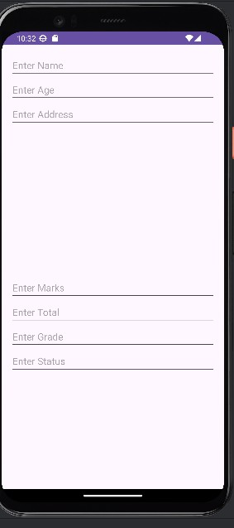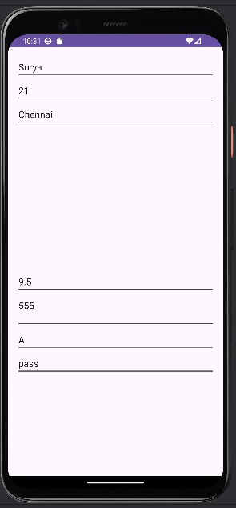

*arguments*=

Bundle().*apply***{**

putString(*ARG_PARAM1*, param1)

putString(*ARG_PARAM2*, param2)

**}**

**}**

}

}

## Output:

16 **DepartmentofComputerScienceandDesign**| **RajalakshmiEngineeringCollege**

.

# Result:

TheApplicationwasdevelopedusingKotlininAndroidStudio.

**DepartmentofComputerScienceandDesign**| **RajalakshmiEngineeringCollege**

.

1